

Students Name:………………………………………

SPECIALIST MATHEMATICS

WRITTEN TRIAL EXAMINATION 1

2006

Reading Time: 15 minutes
Writing time: 1hour

Instructions to students
This exam consists of 9 questions.
All questions should be answered.
There is a total of 40 marks available.
The marks allocated to each of the nine questions are indicated throughout.
Where more than one mark is allocated to a question, appropriate working must be shown.
Unless otherwise indicated, diagrams in this exam are not drawn to scale.
Students may not bring any notes or calculators into the exam.
The acceleration due to gravity should be taken to have magnitude 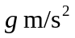where 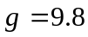
Formula sheets can be found on pages 12-14 of this exam.

This paper has been prepared independently of the Victorian Curriculum and Assessment Authority to provide additional exam preparation for students. Although references have been reproduced with permission of the Victorian Curriculum and Assessment Authority, the publication is in no way connected with or endorsed by the Victorian Curriculum and Assessment Authority.

© THE HEFFERNAN GROUP 2006
This Trial Exam is licensed on a non transferable basis to the purchaser. It may be copied for educational use within the school which has purchased it. This license does not permit distribution or copying of this Trial Exam outside that school or by any individual purchaser.
Question 1

A particle of mass 2 kg moves in a straight line.

The velocity 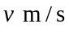, of the particle at time 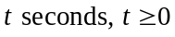 is given by

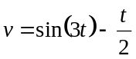.

- Find the acceleration of the particle expressed as a function of t.

1 mark

- Find the maximum resultant force acting on the particle during its motion.

2 marks

Question 2

Consider the relation given by

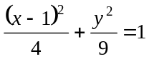.

- Sketch the graph of the relation on the set of axes below. The y-intercepts are not required.

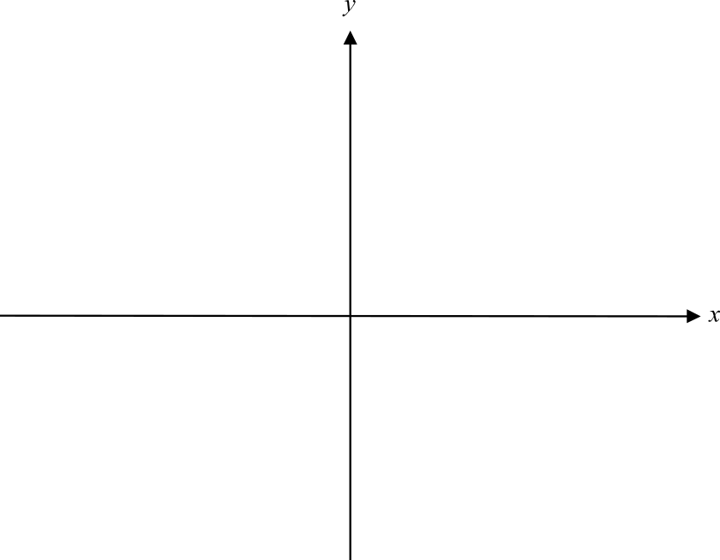

2 marks

- Find an expression for 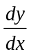 in terms of x and y.

3 marks

- Hence show that if 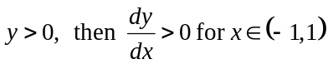.

2 marks
Question 3

- Show that 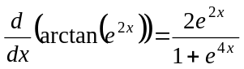.

1 mark

- Hence find the exact value of 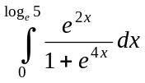.

3 marks

Question 4

- Given that 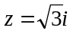 is a solution to the equation

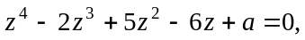

show that 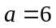.

1 mark

- Hence find all the solutions to the equation

.

3 marks
Question 5

- Find 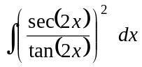.

1 mark

- Evaluate 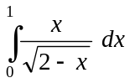.

3 marks

Question 6

Let 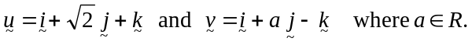
The angle between 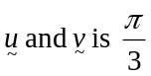.
Find the value of a.

4 marks

Question 7

Solve the differential equation

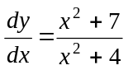
given that 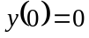.

3 marks

Question 8

The region enclosed by the graph of 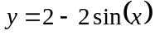 and the positive x and y-axes is shaded in the diagram below.

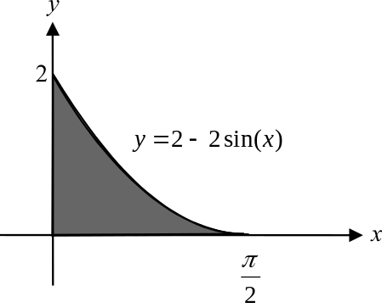

This shaded region is rotated about the x-axis to form a solid of revolution.
Find the volume of this solid of revolution.

4 marks

Question 9

- i. Find the coordinates of the stationary point of the graph of the function

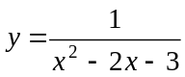.

  - Find the nature of this stationary point.

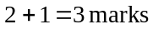

- Express 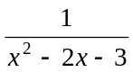 in partial fraction form.

2 marks

- Hence find the area enclosed by the curve with equation , the x-axis and the lines 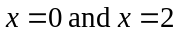.

2 marks

Specialist Mathematics Formulas

Mensuration
area of a trapezium: 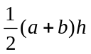
curved surface area of a cylinder: 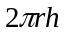
volume of a cylinder: 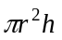
volume of a cone: 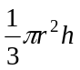
volume of a pyramid: 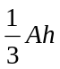
volume of a sphere: 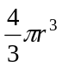
area of a triangle: 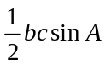
sine rule: 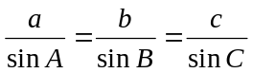
cosine rule: 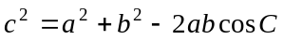

Coordinate geometry
ellipse: 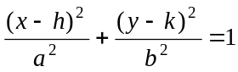 hyperbola: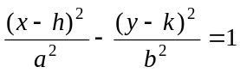

Circular (trigonometric) functions
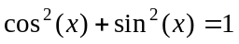
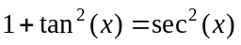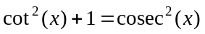
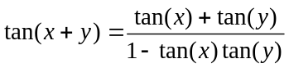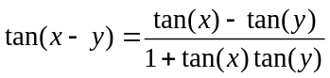
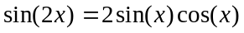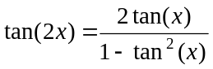
function | 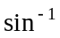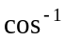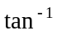
domain  range | 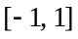  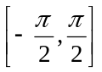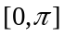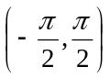
Algebra (Complex numbers)
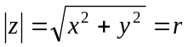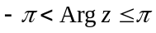
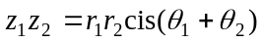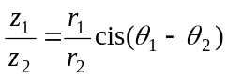
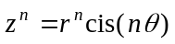 (de Moivre’s theorem)

Reproduced with permission of the Victorian Curriculum and Assessment Authority, Victoria, Australia.
This formula sheet has been copied in 2006 from the VCAA website www.vcaa.vic.edu.au
The VCAA publish an exam issue supplement to the VCAA bulletin.
Calculus

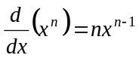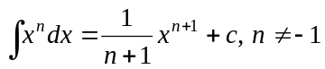
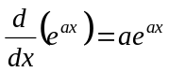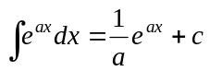
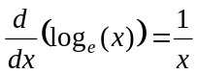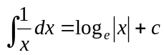
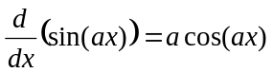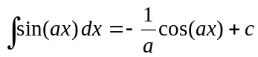
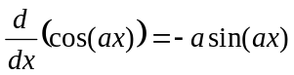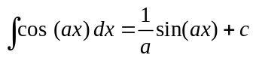
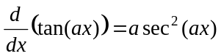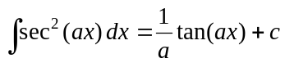
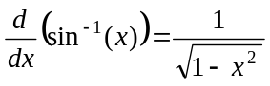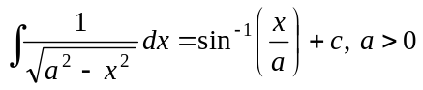
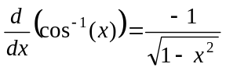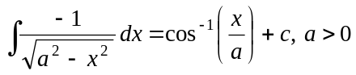
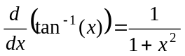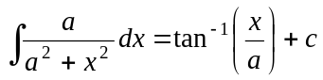

product rule: 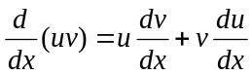
quotient rule: 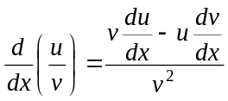
chain rule: 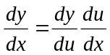
Euler’s method: 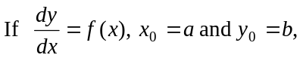
acceleration: 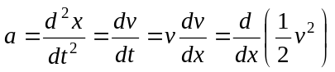
constant (uniform) acceleration: 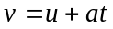 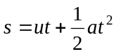 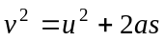 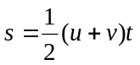

Reproduced with permission of the Victorian Curriculum and Assessment Authority, Victoria, Australia.
This formula sheet has been copied in 2006 from the VCAA website www.vcaa.vic.edu.au
The VCAA publish an exam issue supplement to the VCAA bulletin.

Vectors in two and three dimensions

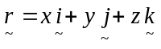
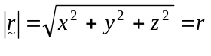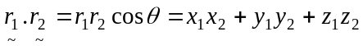
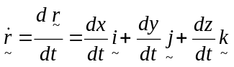

Mechanics

momentum: 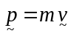
equation of motion: 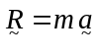
friction: 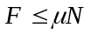

Reproduced with permission of the Victorian Curriculum and Assessment Authority, Victoria, Australia.
This formula sheet has been copied in 2006 from the VCAA website www.vcaa.vic.edu.au
The VCAA publish an exam issue supplement to the VCAA bulletin.

